Import Data using Transform Maps (Spreadsheet)
Phase 8: Project Demonstration Phase

1. Overview
The final demonstration presents the complete project workflow. The demonstration starts with the employee spreadsheet and continues through the Import Set, Transform Map, transformation and target table.
The demonstration also shows Coalesce behavior with existing and new data. Finally, the three reports and the Employee Analytics Dashboard are displayed to show the completed project output.

2. Key Activities
- Show the employee spreadsheet.
- Show the Employee Test table.
- Show the Import Set table.
- Show the Transform Map and mappings.
- Run Transform and show the result.
- Verify imported records.
- Demonstrate Coalesce.
- Show reports and dashboard.
3. Detailed Process
In this phase, the project work related to **Project Demonstration Phase** is carried out according to the overall ServiceNow project workflow. The activities are recorded in sequence so that the implementation can be understood and demonstrated clearly.

4. Expected Outcome
The phase should produce a clear and documented output that can be verified before moving to the next phase. The project remains focused on importing spreadsheet employee data into ServiceNow using Import Sets and Transform Maps.

5. Project Evidence / Screenshots
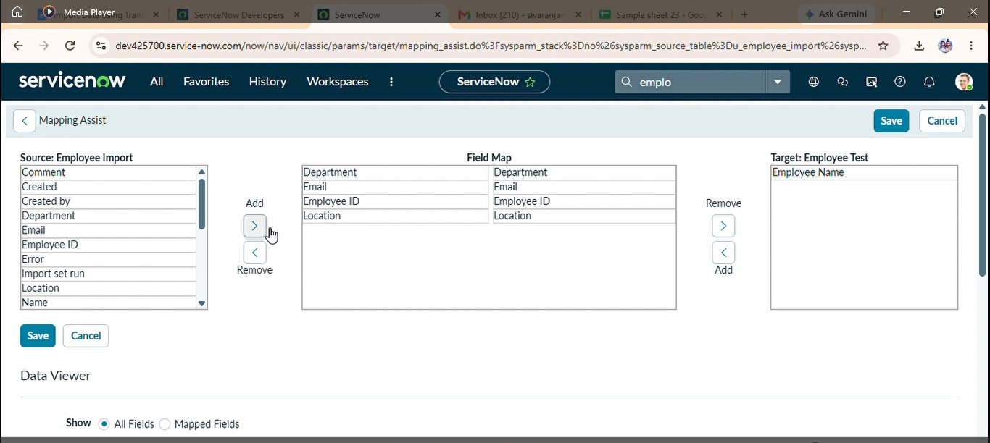

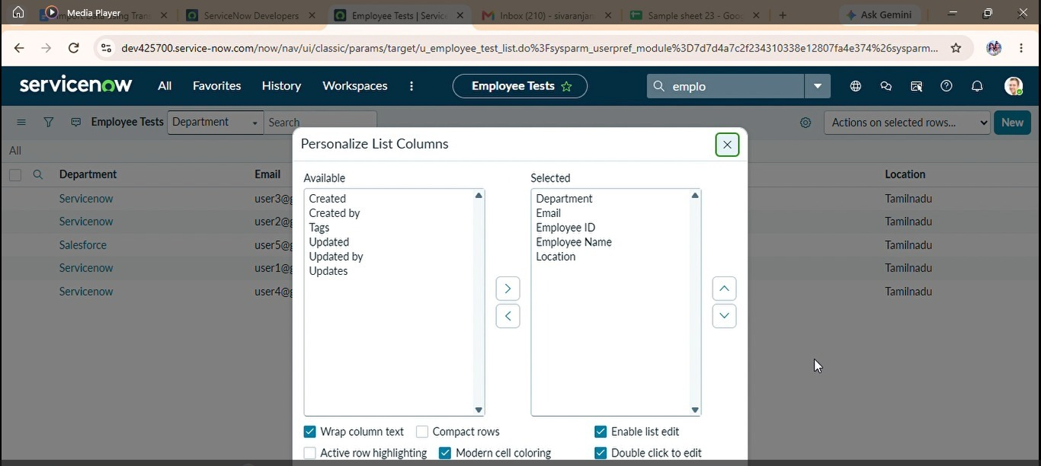

6. Phase Summary
Phase 8 completes the activities required for Project Demonstration Phase. The documented output and screenshots provide evidence of the project work and support the transition to the next phase.

Expected / Produced Output
All employee records are successfully imported into the ServiceNow system using Import Sets and Transform Maps. The project also demonstrates duplicate prevention using Coalesce and provides reports and a dashboard for viewing employee information.

9. Conclusion

Conclusion
The “Import Data using Transform Maps (Spreadsheet)” project successfully demonstrates how employee data can be efficiently imported from an external spreadsheet into the ServiceNow platform. The project uses Import Sets to temporarily store the uploaded spreadsheet data and Transform Maps to map the source fields with the corresponding fields in the target Employee Test table.
The project also demonstrates the complete data import process, including spreadsheet preparation, table creation, field mapping, data transformation, validation and verification of imported records. The use of Coalesce helps to identify existing employee records and prevents unnecessary duplicate records when the same data is imported again.
In addition, reports such as Employees by Department, Employees by Location and Employee List Report provide a clear representation of the employee information. These reports are combined into a dashboard, which helps users view and understand the imported data in a centralized manner.
Overall, this project provides a practical understanding of how ServiceNow can be used to manage external employee data efficiently. It reduces manual data entry, improves data consistency, supports duplicate handling and provides better visibility through reports and dashboards.

Future Enhancement
The project can be further enhanced by adding more automation and advanced data management features. Future enhancements may include:
- Automated Data Import:
The system can be enhanced to automatically import employee data at scheduled intervals instead of uploading the spreadsheet manually.
- Data Validation:
Additional validation rules can be added to check incorrect email formats, missing employee IDs, duplicate values and invalid data before transformation.
- Import Error Handling:
A separate error-handling mechanism can be implemented to identify failed records and provide meaningful error messages for correction.
- Advanced Dashboard:
The existing dashboard can be enhanced with additional charts and visualizations to provide more detailed employee insights.
- Email Notifications:
Automated email notifications can be added to inform administrators about successful imports, failed records or duplicate data.
- Integration with External Systems:
In the future, the project can be extended to receive employee information directly from external HR systems or databases instead of relying only on spreadsheets.
- Role-Based Access:
Access permissions can be implemented so that only authorized users can import, modify or view employee information.
- Real-Time Data Synchronization:
The system can eventually be enhanced to synchronize employee information between ServiceNow and external systems, reducing the need for repeated manual imports.

